By Cole Samson

Data Visualisation Assignment

17/12/23

Contents

Pages

1. Policies and Procedures ………………………………………………………………………………………… 2
2. Excel Task ……………………………………………………………………………………………………………… 3
3. Tableau Task ………………………………………………………………………………………………………... 11
4. Reflection …………………………………………………………………………………………………………….. 20

**1. Policies and Procedures**

In the data industry, following policies and procedures upholds standards and upholds the ethical use of data. They are a set of rules that codify a recognised specification for when corporations and individuals use data. This includes subjects such as the data collection, data quality control, data security and data privacy as well as a variety of others.

**i. Data Collection**

Policies and procedures within data collection cover the process in which data is gathered. This includes processes such as requesting, granting access and implementing data. They give guidance to how data retrieval should be documented as well as recommendation of how to converse with different entities that have the desired data. Furthermore, they cover any real-life process of the data collection itself. For example, a person asking questions to the public.

**ii. Data Retention and Maintenance**

This covers all the policies and procedures that are required to be followed when archiving and storing data. These include following any legal requirements as well as amenability with any internal individuals or external clients.

**iii. Data Destruction**

The policies and procedures that ensure that data is destroyed when required by GDPR, as well as removing irrelevant data that is not needed.

**iv. Data Documentation**

The policies and procedures that set a standard for how the data is recorded. This includes providing any pertinent contextual information, the recording of when the data is collected and the organisation of the data files. This enables any other entity that has access to the data to have a clear understanding of the data they have been given.

**v. Data Sharing**

The policies and procedures that cover how different individuals and organisations communicate and send data with each other. Furthermore, these cover creation of any data agreement between multiple parties.

**vi. Data Privacy and Security**

The policies and procedures that ensure that all data is stored securely and follows all laws and regulations, such as GDPR. This also includes the transfer of data as well as any situation where data is involved. Furthermore, the policies and procedures must ensure that consent is acquired before using any data.

**Significance**

As a data analyst, it is important to follow policies and procedures to ensure that you follow laws and produce work to a high standard. Furthermore, they guarantee that data analyst work to high ethical standards,

**2. Excel Task**

**Step 1.** Click on Review tab, click on Protect Workbook button and set password.

**Step 2.** Click on column C to highlight column C. Highlight column C and change the data by using the drop down option in the number section. Change data type to currency to display with British Pound.

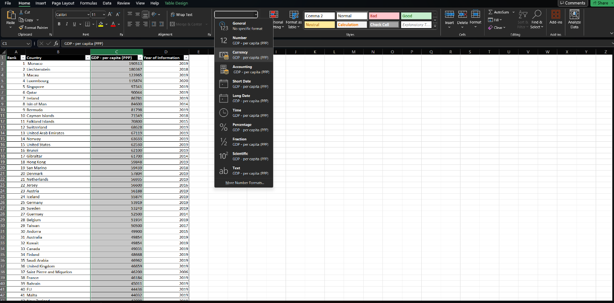

**Step 3.** Create the table by selecting the Insert tab on the ribbon, press the table button and enter the dimensions of the table ($A$1:$D$229) . Alternatively highlight all the data you want in the table and press the table button. As row 1 is within the selection make sure you tick the my table has headers button.

**Step 4.** Click on the arrow of the Year of Information column and only tick the 2019 box.

**Step 5.** Create a chart by selecting the data,. clicking on the Insert tab and clicking on the chart type.

**Step 6a.** To edit the chart and make it visually appealing, select the auto created title and enter the desired title.

**Step 6b.** Next add axis labels by clicking on the Add Chart Element button under the Chart Design tab and select the Axis Title button and repeat for both horizontal and vertical titles.

**Step 6c.** Next double click on the chart and customize the chart using the different preset chart styles shown on the ribbon or customize the different aspects of the chart using the Format Chart pane on the right of the screen.

Note due to the large quantity of data the chart will only look neat later once we filter the chart to include less data.

**Step 7.** Move the chart to a new sheet by selecting the Move Chart button under the Chart Design tab. Choose the new sheet option and name the new worksheet. Note you may need to unprotect your workbook if it is still protected.

**Step 8.** Create a sort for the top 20 ranking countries by selecting the GDP worksheet. Then click on the arrow next to the Rank header. Click on the Number Filters menu and click on the Top 10 option. Then a menu titled Top 10 AutoFilter will appear. Change top to bottom and the number to 20. Then click ok.

**Step 9.** Highlight data and insert a new chart using the steps completed previously.

**Step 10.** Highlight the cells underneath the graph and fill with desired colour using fill colour button.

This should be the finished spreadsheet.

**3. Tableau Task**

**Step 1.** To import the data click on the Data tab and the New Data Source Button. Click the upload from Computer button and select your data file.

**Step 2.** To set relationships between the three tables. First drag the Life Expectancy table into the workspace and then drag the GDP table. Next you must set the relationship between the two tables. In this case, the Country Data from the Life expectancy table and the Country GDP Data from the GDP table. Repeat this step with the Smartphones table, using Country and Country (smartphones) to establish a relationship.

**Step 3.** Next, the data types must be changed so they are in the correct datatype. To do this you must click on the icon next to the field name. On the Life Expectancy table, Rank should be designated as Number (whole). Country should be a Country Geographic Role (which is a string). Life Expectancy should be designated as a Number (decimal). Finally Date of Information should be designated as a Number (whole) datatype.

For the GDP table, Rank should be a Number (whole). Country should be a Country Geographic Role (which is a string). GDP – per capita (PPP) should be a Number (decimal). Year of Information should be designated as a Number (whole) datatype.

For the Smartphones table, Rank should be a Number(whole). Country should be a Country Geographic Role (which is a string). Smartphone Users should be a Number (whole), and the Date of Information should be a Number (whole) datatype.

**Step 4.** To build a chart, select the data fields you want to use. In this chart, I will be mapping a country’s life expectancy to their GDP. Drag the desired data fields to the Columns and Rows bar above the sheet title. Next, drag the Country (Life Expectancy) data field to the marks section. Subsequently create filters of both fields and select Special Non-null values, to ensure that there are no null values left in your data selection.

Next, to customise the chart start by changing the marks to circle and edit colour. Also you can add a border or change the opacity. You can also add labels by selecting Label within the marks box. Make sure you choose colours that allow colourblind people to use your graph

Next add filters of Rank in both Life Expectancy and GDP per capita where the filter is by attribute. This allows the user to narrow the graph by rank. Moreover you can rename these filters and can hide them if desired.

Next, right click on the graph and select show trend line. This will add a trend line which can be customised. You can also customise the tooltip by pressing the tooltip button under marks.

Next I created three other basic graphs of Country by Smartphone Users, Country by GDP per Capita and Country per Life Expectancy

**Country by Smartphone Users**

**Country by GDP per Capita**

**Country by Life Expectancy**

I changed the formatting of the Life Expectancy number by formatting the data attribute and changing the data to one decimal place.

**Average Rank**

To make a geographical graph showing the average rank of each country, right click on the data window and select create calculated field. Enter the calculation shown below:

Drag this measure to the size button in the marks tab. Then click on the label button and check show mark labels. This will allow colourblind people to clearly see the graph. To customise the geographical map select the map tab at the top of the page and choose different options, including background maps, images and layers. For non-colourblind people you can add different colours depending on the rank.

**Step 5.**  As seen earlier make sure colours used in graphs are colourblind friendly. This could include using colourblind friendly colour combinations (as seen below) or adding labels.

**Step 6.** To Create a dashboard, click on the icon next to the sheet tabs. The drag the different sheets onto the dashboard. On each sheet click the use as filter icon so you can have an interactive dashboard.

Next To add a title to the dashboard, drag a text object from the bottom left onto the dashboard. Furthermore, if you click on each sheet you can customise them. For example, add borders. Also you can change backgrounds titles and colours from the dashboard.

**4. Reflection**

In this assignment, I was able to demonstrate my knowledge of using tables and graphs in Excel. I also showed my ability to sort and filter data within Excel. Furthermore, I was able to show I could create a dashboard in Tableau and create interactive visuals.

For further development of these tasks, I would like to add complexity to the data gathered by adding more data fields. This would allow me to create a more diverse range of visualisations and produce more in-depth analysis of the data.

**Lessons Learned**

During this assignment, I learnt how to analyse, present and manipulate data in Excel by using the software effectively.

I was introduced to Tableau and discovered how to create interactive visualisations to analyse data. This was completely new skill for me.

This assignment also taught me how to create a professional data analyst report. I will be able to use these skills in my future jobs.

Finally, I also learnt that you have to be patient with software and be prepared for situations where the software does not function like you intend it to. This taught me how to deal with problems that may occur in the future.